Determining the Factors Influencing Self-Esteem Among UiTM Machang’s Students (Times new roman, 14, bold)

Nursyaida Arissya Normahisham, Sophie Qaisara Anuar, Noramalin Ellisya Azman & Nur Elya Emisya Mohd Nizam (Times new roman, 12)

Faculty Science and Media, UiTM Kelantan, Malaysia
Email: nrsyaidaarssya@gmail.com (Times new roman, 12)

Abstract
Self-esteem is extremely important in college students' life, influencing their academic achievement, social interactions, and overall well-being during a critical period of personal and academic growth. Self-esteem, defined as the subjective judgement of one's own value and talents, can have a significant impact on college students' confidence, perseverance in the face of adversity, and ability to negotiate the complexity of higher education. High self-esteem is linked to favourable outcomes such as increased motivation, effective stress management, and a sense of accomplishment in academic and social connections. This study investigates the complex links between academic achievement, depression, parenting style, and self-esteem among students at UiTM Machang. It seeks to understand how these factors interact to influence students' opinions of their worth and skills. In addition, the study investigates whether there are substantial disparities in self-esteem levels between genders and semesters among university students. In this study, a sample of 93 students from UiTM Machang's College of Computing, Informatics, and Mathematics was selected using simple random sampling via Raosoft. This method was chosen for its ability to provide an impartial and equal opportunity for every member of the population to be included, ensuring a representative cross-section of the student body. Understanding the elements that influence self-esteem, including as academic success, peer connections, and the transition to college life, might help develop effective therapies. Institutions that address self-esteem concerns may improve students' academic performance, mental health, and overall well-being. Promoting supportive social networks, providing counselling services suited to resolving self-esteem concerns, and creating conditions that favour academic success while reducing stressors that negatively impact self-perception are all effective techniques for boosting self-esteem. (Times new roman, 11, italic)
Keywords: Self-Esteem; Academic Achievement; Depression; Parenting Style

Introduction (Times new roman, 12)
Self-esteem significantly influences college students' academic performance, mental health, and social interactions by shaping their perception of competence and worth (Orth & Robins, 2014). High self-esteem is linked to better mental health, effective stress management, and greater life satisfaction, whereas low self-esteem correlates with depression, anxiety, and poorer academic outcomes (Orth & Robins, 2014). Academic success and peer relationships play critical roles in students' self-esteem; success tends to enhance it, while challenges and negative interactions can diminish it (McLeod, 2012). Addressing self-esteem issues is crucial for improving overall well-being and academic success among college students (Sowislo & Orth, 2013). Poor self-esteem is increasingly prevalent among college students due to inadequate support systems that fail to meet modern challenges (Ferkany, 2008; Emil, 2003), leading to rising student complaints, dropout rates, and declining academic performance (Naderi et al., 2009; Arshad et al., 2015). Lower self-esteem is associated with lower grades, reduced engagement, and reluctance to seek help, along with mental health issues such as depression and anxiety (Bahrainian et al., 2014; Bhatt & Bahadur, 2018). Factors contributing

to poor self-esteem include depression, parenting style, and academic achievement (Hong et al., 2015; Karimi & Saadat, 2020). Addressing these factors is essential for improving college students' academic success and overall well-being. Ongoing research aims to find practical solutions to enhance self-esteem, academic outcomes, and mental health among college students (von Soest et al., 2020; Marsh et al., 2020). (Times new roman, 12)

Methodology
Study designs involve methods and procedures for collecting and analyzing data. They help researchers choose the best approaches and organize their investigations. In this study, we use cross-sectional research, an observational method that simultaneously collects data from a population or subset. This provides a snapshot of a phenomenon or population at a specific moment. In statistics, a population is the group from which a research sample is drawn. This study's target population includes 592 students from Part 1 to Part 5 at the College of Computing, Informatics, and Mathematics at Universiti Teknologi Mara (UiTM) Machang Campus. Respondents from the CDCS111, CDCS110, and CDCS143 courses were chosen to investigate factors affecting students' self-esteem. The sampling process, detailed below, involved selecting 93 students using the Raosoft Sample Size calculator. Simple random sampling was used for this selection. We detail the method for gathering a representative sample here. The sample consists of 93 students from UiTM Machang's College of Computing, Informatics, and Mathematics, calculated using Raosoft. We employed simple random sampling because it is economical and ensures every population member has an equal chance of being chosen. Every mathematics student at UiTM Machang received a questionnaire with two parts. Part A has four demographic questions: gender, age, course, and semester. Part B has four sections with twenty questions: Section A on self-esteem, Section B on depression, Section C on academic performance, and Section D on parenting style. Responses for Part B are given on a Likert scale from one to nine. Lastly, we analyse self-esteem at UiTM Machang using various statistical methods. Descriptive statistics are used to explore the demographic characteristics of the respondents. We employ multiple linear regression to determine the relationship between academic achievement, depression, parenting style, and self-esteem. Additionally, we use a one-way ANOVA test to identify differences in self-esteem among students from different semesters. Table 1 summarizes the number of items and sources of instrumentation of the study while Figure 1 shows the conceptual framework of the study.

Table 1: Instrumentation (Times new roman, 11)

Variables | Sources | Number of items
Self-esteem | (Arshad et al, 2015) | 5
Depression | (Bahrainian et al, 2014) | 5
Academic performance | (Hong et al, 2015) | 5
Parenting style | (Arshad et al, 2015) | 4

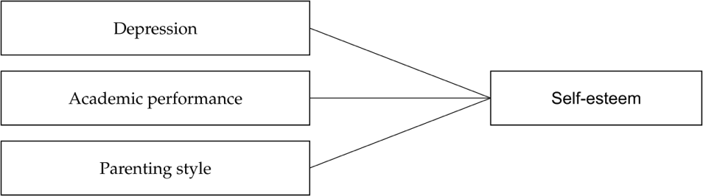

Figure 1: Conceptual framework (Times new roman, 11)

Results

Reliability
Cronbach's alpha measures the internal consistency of a set of items. For self-esteem (0.866) and parenting style (0.803), the reliability is good, indicating the items are well-related. Since Cronbach alpha for depression (0.706) is greater than 0.7, it has acceptable reliability, meaning the items are adequately consistent. Academic performance (0.666) falls into the questionable range, suggesting the items may not be as consistently measuring the construct and might need improvement.

Table 2: Cronbach Values for each variable

Variables | Cronbach Values
Self-esteem | 0.866
Depression | 0.706
Academic performance | 0.666
Parenting style | 0.803

Demographic Characteristic
Table 2 indicates that of the 93 respondents, 56 are female and 37 are male, which adds to the conclusion. With a proportion of 60.2%, females contribute the most, followed by men. Respondents range in age from 18 to 25 years old. Of them, 20-21 years old make up the largest percentage group at 66.7%, followed by 18-19 years old (22.6%), 22-23 years old (7.5%) and 24- 25 years old. 43.0%, 28.0% and 29.0% of the respondents who complete the surveys are students enrolled in CDCS111, CDCS110, and CDCS143. Part 4 respondents made the most contribution (57.0%), which was followed by Part 2 (28.0%), part 3 (4.3%), part 1 (5.4%) and
Part 5 (5.4%).
Table 2: Demographic

Characteristics | Group | Frequency | Percentage (%)
Gender | Female | 56 | 60.2
 | Male | 37 | 39.8
Age | 18-19 | 21 | 22.6
 | 20-21 | 62 | 66.7
 | 22-23 | 7 | 7.5
 | 24-25 | 3 | 3.2
Course | CDCS111 | 40 | 43.0
 | CDCS143 | 26 | 28.0
 | CDCS110 | 27 | 29.0
Part | Part 1 | 5 | 5.4
 | Part 2 | 26 | 28.0
 | Part 3 | 4 | 4.3
 | Part 4 | 53 | 57.0
 | Part 5 | 5 | 5.4

Linearity
The Pearson correlation scores for each variable. Specifically, the Pearson correlation score for Self-esteem and Depression has a correlation coefficient of 0.648, with a p-value of less than 0.001, indicating a strong positive correlation. Self-esteem and Academic performance have a correlation coefficient of 0.508, with a p-value of less than 0.001, indicating a strong positive correlation. Self-esteem and Parenting style have a correlation coefficient of 0.437, with a p- value of less than 0.001, indicating a strong positive correlation. Notably, the p-values for all variables were below 0.001, which is also lower than the significance level of 0.05. Consequently, it can be concluded that a significant positive relationship exists among Self- esteem, Depression, Academic performance, and Parenting style.
Table 3: Pearson Correlation of Analysis

Variable | Depression | Academic Performance | Parenting Style
Self-esteem Pearson correlation | 0.648 | 0.508 | 0.437
p-value level | < 0.001  strong | <0.001  strong | <0.001  strong
Homoscedasticity
In this study, the scatter plot of Regression Standardized Residuals versus Regression Standardized Predicted Value shows that the errors are distributed over the entire range of the predicted value, with no obvious pattern or relationship between the residuals and the predicted values, as shown in Figure 4. As a result of these findings, the study's homoscedasticity assumption has been satisfied.
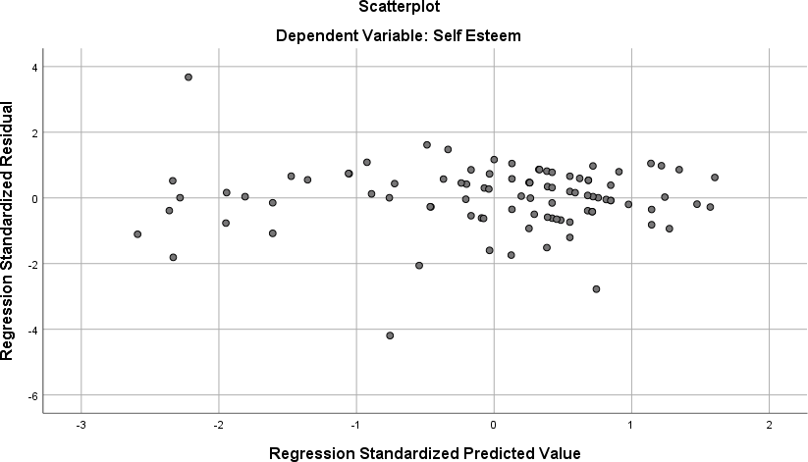
Figure 4: Scatter plot for Self-Esteem

Conclusion and Recommendations
Self-esteem, a critical component of an individual's psychological constitution, refers to one's total sense of self-worth and personal importance. It has a profound impact on several aspects of life, including mental health, academic achievement, and social connections. The study emphasizes the essential issue of low self-esteem among college students, which has a

significant impact on their academic performance and mental health. Low self-esteem not only causes lower grades and less participation, but it also contributes to mental health disorders such as depression and anxiety, compounding feelings of isolation and inadequacy. Low self- esteem not only causes lower grades and less participation, but it also contributes to mental health disorders such as depression and anxiety, compounding feelings of isolation and inadequacy. The growing number of student complaints, higher dropout rates, and diminishing academic performance highlight the critical need for current and effective support measures. In conclusion, to address these challenges, complete support systems must be developed, including strong academic counselling, mental health services, and interventions aimed at increasing self-esteem.

References

Alghamdi, S. A., Aljaffer, M. A., Alahmari, F. S., Alasiri, A. B., Alkahtani, A. H., Alhudayris, F. S., & Alhusaini, B. A. (2023). The impact of low self-esteem on academic achievement and thebehaviors relatedto it among medical students in Saudi Arabia. Saudi medical journal, 44(6), 613.
https://doi.org/10.15537/smj.2023.44.6.20230055

Arshad, M., Zaidi, S. M. I. H., & Mahmood, K. (2015). Self-esteem & academic performance among university students. Journal of education and practice, 6(1), 156-162 https://doi.org/10.7176/JEP

Bahrainian, S. A., Alizadeh, K. H., Raeisoon, M. R., Gorji, O. H., & Khazaee, A. (2014). Relationship of Internet addiction with self-esteem and depression in university students. Journal of preventive medicine and hygiene, 55(3), 86–89. https://doi.org/10.15167/2421-4248/jpmh2013.54.2.375

Bhatt, S., & Bahadur, A. (2018). Role of Self Esteem & self-efficacy in achievement motivation among college students. The International Journal of Indian Psychology, 6(2), 5-13. doi: 10.25215/0602.061
Ferkany, M. (2008). The educational importance of self-esteem. Journal of Philosophy of Education,42(1), 119-132. https://doi.org/10.1111/j.1467-9752.2008.00610.x

Garcia, F., & Serra, E. (2020). Parenting styles and self-esteem: A longitudinal study of Spanish,a,, dolescents. Journal of Child and Family Studies, 29(1), 17 doi: 10.3390/ijerph17072370

Hong, O. S., Long, C. S., & Rahman, R. H. A. (2015). An Analysis on the Relationship betweenParenting Styles and Self Esteem of Students of a University in Malaysia: A Case Study. Doi:10.5901/mjss.2015.v6n4s3p300

Karimi, F., & Saadat, M. (2020). The impact of authoritative parenting on adolescents’ self-esteem andacademic performance. Educational Psychology, 40(2), 129-140
https://www.tandfonline.com/doi/full/10.1080/01443410.2019.1642101

Liu, X., & Li, Q. (2020). The impact of emotional intelligence on the relationship between self- esteem and academic performance. Personality and Individual Differences, 160, 109896. DOI: 10.5267/j.msl.2016.5.005

Marsh, I. C., Chan, S. W. Y., & MacBeth, A. (2020). Self-compassion and psychological distress in adolescents a meta-analysis. Mindfulness, 11(2), 240-255. Doi: 10.1007/s12671-017-0850-7

Martin, A. J., Papworth, B., Ginns, P., & Malmberg, L. E. (2020). Motivation, engagement, and social climate: An international study of boarding schools. Journal of Educational Psychology, 112(3), 532-547.https://doi.org/10.1037/edu0000388

Naderi, H., Abdullah, R., Aizan, H. T., Sharir, J., & Kumar, V. (2009). Self-esteem, gender and academic achievement of undergraduate students. American Journal of Scientific Research, 3(1), 26-37

Orth, U., & Robins, R. W. (2014). The development of self-esteem. Current Directions in Psychological Science,23(5), 381-387. https://journals.sagepub.com/doi/10.1177/0963721414547414

Sowislo, J. F., & Orth, U. (2013). Does low self-esteem predict depression and anxiety? A meta- analysis of longitudinal studies. Psychological Bulletin, 139(1), 213. Doi:10.1037/a0028931

von Soest, T., Wichstrøm, L., & Kvalem, I. L. (2020). The development of global and domain-specificself- esteem from age 13 to 31. Journal of Personality and Social Psychology, 118(3), 593-611. https://doi.org/10.1037/pspp0000223

